implementation of standard iso 9001 in local self-government – example of municipalities in republic of serbia

Abstract: In modern society, the functioning of a country relies heavily on the evolving activities and role of public administration. Implementing the ISO 9001 standard for Quality Management System demands significant effort and organizational capacity. This paper evaluates the implementation of ISO 9001 in local self-government institutions in Serbia, focusing on municipalities. It also examines the ISO 18091 standard, offering guidance for applying ISO 9001 in local government. Analysis was conducted using a questionnaire from ISO 18091's Annex A, enabling self-evaluation. Employees from various Serbian municipalities filled out the questionnaire, allowing local government authorities to assess performance across 39 indicators.

Keywords: local government, standard ISO 9001, standard ISO 18091, municipalities

1. INTRODUCTION
The modern society of a country follows the constant changes, life and work of its citizens. Accordingly, the ways of implementing activities in an expanded scope and the role of public administration are of great importance for the state. According to Gębczynska & Wolniak, (2018), there is “a growing awareness among the citizens of a country about their rights and duties of the Government. In this situation, the role and scope of actions carried out by the public administration evolves in response to the changing needs and demands of society".

In the existing matrices of the public administration system, the output is the efficiency of the process and the result of the undertaken activities. In addition to a large number of approaches, according to Ćwiklicki, et al. (2021) "is also ISO 9001 - Quality Management System, which is one of the most recognized systems". Implementing Quality Management System according to the requirements of the ISO 9001 standard (QMS) requires a certain effort and the capacities of organizational resources. That is why, according to Ćwiklicka, et al. (2021), "the notion of organizational resource capacity (or, in short, organizational capacity) is particularly crucial for local governments that have fewer resources than regional and national public administration bodies.

It should be borne in mind that the importance of factors that support the implementation of ISO 9001 may differ among different business sectors (Almeida et al. 2018). Furthermore, even companies from the same industry assess the importance of barriers to ISO 9001 certification differently (Sfakianaki & Kakouris 2018).
The aim of this work is to evaluate and identify the implementation of the QMS according to the requirements of ISO 9001 in the local self-government institutions of Republic of Serbia, that is, in the Serbian municipalities. Application of ISO 18091 standard, which provides guidelines for the application of the ISO 9001 standard in local self-government, is presented. The analysis was carried out on the basis of the questionnaire found in Annex A of the ISO 18091 standard, which represents a diagnostic system that can be used for self-evaluation and thus the highest local government authorities have possibility to identify the level of performance for each of the 39 indicators that are given in questionnaire, which, in this case, was filled out by employees in different Serbia municipalities.

2. QUALITY MANAGEMENT
Throughout history, the world has undergone constant transformation, accelerated by advancements in technology, markets, and the economy. Over the past two decades, companies have faced mounting pressure from stakeholders to address their environmental impact (Abbas & Sagsan, 2019). Concerns about climate change and pollution have prompted a shift towards renewable resources (Li et al., 2018; Ji & Zhang, 2019). International, national, and local regulations aimed at environmental preservation have compelled companies to adopt greener production processes (Fernando et al., 2019). Quality management has evolved since Schuhart's time in 1931, with new tools emerging to meet changing market demands. Processes of globalization and the knowledge-based society, as well as the transition of the economy, open questions for organizations, "how to improve quality of their products/services and consistently meet the expectations of their customers".

Mentioning quality, according to the ISO 9000:2015 standard (ISO, 2015), this term represents "degree to which a set of inherent characteristics of an object fulfils requirements." According to the same standard, management (ISO, 2015) "implies coordinated activities to direct and control an organization." This standard also states that quality management is "management with regard to quality". Therefore, it can be said that quality management implies, according to ISO 9000:2015, "coordinated activities to direct organization in relation to quality and control organization in this sense" (ISO, 2015).

Quality management encompasses various methods tailored to specific contexts and issues (Klochkov & Tveryakov, 2020). Techniques like Six Sigma, Kaizen, and Quality Control are being common choices (Potkany et al., 2020). However, achieving excellent quality requires a cultural shift within organizations, prioritizing understanding and adoption of quality principles over blind adherence to techniques (Gunasekaran et al., 2019). Namely, numerous international, regional and national organizations and governments have raised the issue of sustainable business and social responsibility (European Commission). Accordingly, Delerid & Fundin (2015) proposed the concept of quality 5.0, which will have a focus on sustainability. Also, in accordance with the Agenda 2030 of the European Commission, there is talk about Quality 2030 and the ways in which the goals of this Agenda will be applied in relation to quality (Fundin et al., 2020).
3. LOCAL SELF-GOVERNMENT
There are several concepts that can be correlated with local self-government and between which it is necessary to make a distinction. These are the concepts of public administration, public sector and local self-government. According to Vukosavljević et al. (2021:41), "the public sector is a means by which each state acts on the most important areas of joint work and activities of all its citizens." In modern states, citizens expect comprehensive services and protection, which public administration delivers through various social and regulatory measures, while managing state-owned and regulating private industries. Further, local self-government "is the right of citizens to manage public affairs of direct, common and general interest to the local population, directly and through freely elected representatives in local self-government units, as well as the right and ability of local self-government bodies to, within the limits of the law, manage affairs and manage public affairs that are within their jurisdiction and of interest to the local population" (Law on Local Self-Government, 2021).
The internationalization of local self-government began in 1985 with the adoption of the European Charter of Local Self-Government by the Council of Europe, effective in 1988. Since then, the Council has continuously supported its development. An additional protocol (CETS No. 207) supplements the charter, guaranteeing rights such as local referendums and participation in governance. Multi-level governance, recommended by the Committee of Ministers in 2022, promotes cooperation between central, regional, and local governments, and civil society. This fosters participatory policymaking and coordination.

According to Pittaway et al. (2020), local governments are ideally positioned to integrate government, private, and citizen data for innovative public services. To achieve this, managers need training in leading the implementation of integrated enterprise systems. Andrews et al. (2020) highlight the entrepreneurial activities of local self-government bodies, such as establishing companies for public service provision, reflecting diverse global approaches. This underscores the significant role of local government in society, particularly in the economy and citizen services.

3.1 Local self-government in Republic of Serbia
In the late 18th and early 19th centuries, Serbia established local self-government, with villages governed by princes. This evolved over time, with changes in structure and funding. In 1990, the Serbian Constitution solidified the municipality as the basic unit of local governance. The 2006 Constitution further guaranteed citizens' right to local self-government, with laws detailing organization and activities. The Ministry of State Administration and Local Self-Government, founded in 2014, oversees this, including managing citizen registers and supporting local government capacity and funding.
4. QUALITY MANAGEMENT AND LOCAL SELF-GOVERNMENT
The introduction of quality management in public services aims to improve organizational quality and enhance national competitiveness (Lee Yong Wook et al., 2014). Public sector is expected to constantly improve the quality of its services, in order to meet the needs and expectations of its end users - citizens. In this situation, the role and scope of actions of the public administration evolves in response to the changing needs and demands of society (Gębczyńska, & Wolniak, 2018). There are numerous methods, as well as numerous standards and models of excellence that provide requirements and guidelines for the implementation of quality management systems. Certainly, the most widely used method is ISO 9001 standard. According to data of the International Organization for Standardization - ISO (2022a), in 2022, number of certificates of the ISO 9001 standard was 1,265,216 and represents the largest number of certificates of all standards covered. Number of certificates in the public administration sector was 4512. The complexity of applying this standard to all processes of the organization is also indicated by the fact that there are different standards with guidelines for organizations to apply ISO 9001 depending on their activities. For public administration, there is a standard ISO 18091:2022 - Quality management systems - Guidelines for implementation in local self-government.

Various authors highlighted benefits and importance that ISO 9001 can have on various local self-government organizations (Cho & Pyun., 2022). Although it should be emphasized that the certificate in itself means nothing, if this standard is not really applied in practice. Thus, Mizuno (2002) investigated the implementation of ISO 9001 in Japanese local governments and came to the conclusion that local governments can achieve same benefits as private companies from the application of this standard. However, the authors (Loffler & Vintar, 2004; McAdam & Valker, 2003) agree that this standard has a greater effect if it is integrated with other management systems, such as ISO 14001 - Environmental Management System.
Citizens' increasing awareness of public administration has prompted global local self-government organizations to focus on enhancing operational efficiency and quality management systems.
5. STANDARD ISO 18091 - QUALITY MANAGEMENT SYSTEM – GUIDELINES FOR IMPLEMENTATION IN LOCAL SELF-GOVERNMENT

Organizations, irrespective of size or activity, often turn to ISO 9001 certification to implement and regulate their quality management systems (QMS). This standard outlines requirements for establishing a QMS, considered a benchmark of "good practice." Additionally, for organizations seeking further improvement and excellence, there is ISO 9004:2018-Quality management-Quality of an organization-Guidelines for achieving sustainable success.

The ISO 18091:2022 standard aims to bridge quality management concepts from ISO 9000 series with local self-government practices and terminologies, assisting local governments in implementing effective quality management systems (ISO, 2022). These guidelines align with ISO 9001 requirements and apply to all local government processes across strategic, tactical-management, and operational levels, ensuring a comprehensive quality management system focused on achieving local administration goals (see Figure 1).

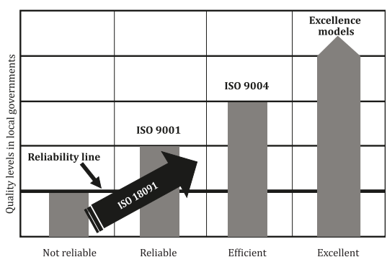
Figure 1: Role of the standard ISO 18091:2022 (ISO, 2022)
By applying this standard and its guidelines, local governments can improve their operations and strive for excellence. However, as shown in Figure 1, this standard does not lead to excellence. To assure that, local self-governments can utilize models like the European Model for Quality Management or the Malcolm Baldrige Excellence Model. Compliance with ISO 9001 standard be considered the ultimate goal. So, when local government achieve a level that allows consistent providing of compliant products and services to local community, it should consider using ISO 9004 and/or other models of excellence to enhance overall effectiveness and efficiency. (ISO, 2022).

ISO 18091 has four appendices. Annex A, which is used for this research, provides a diagnostic model that can be used as a starting point for implementing a comprehensive quality management system for responsible local government. It also has Annexes B, C and D.
6. METHODOLOGY
For the research, its been used questionnaire found in Annex A of the ISO 18091. According to the ISO 18091 (2022) standard, this is a diagnostic system that can be used for self-evaluation and in this way the highest local government bodies have the possibility to identify the level of performance for each of indicators. This questionnaire contains 39 management indicators that are supported by about 130 United Nations documents and are classified into four groups of questions:
1. Institutional development for good governance;
2. Sustainable economic development;
3. Inclusive social development;
4. Sustainable development of the environment.
These indicators include products/services that a typical local self-government should provide to its users - citizens in order to be considered reliable.

As shown in Figure 2, there are three possible answers for each indicator: "red", "yellow" or "green". "Red" indicates essential practices are missing or are performed in an inadequate way by the local self-government to be considered reliable. "Yellow" cells indicate that the local government has made some efforts to implement the essential elements and is capable of providing the product/service as required. "Green" cells indicate that the minimum acceptable conditions have been met and that the local government can be considered reliable. Additionally, a "grey" level denotes best practice but isn't shown in the questionnaire, as this standard doesn't cover it. Figure 3 illustrates the indicators.

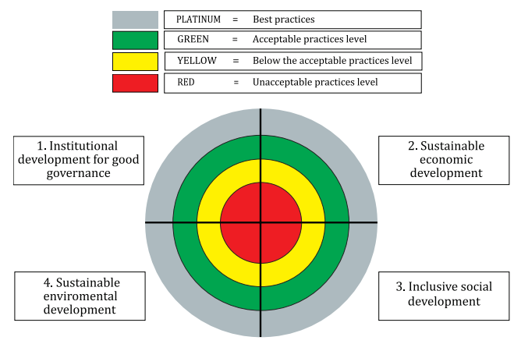
Figure 2: Local government assessment tool for integral quality management (ISO, 2022)

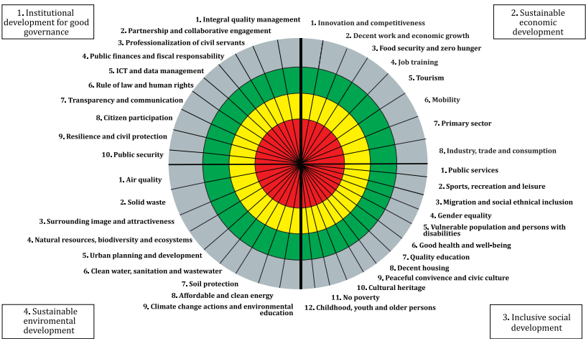
Figure 3: Local government assessment tool for integrated management system (using 39 indicators) (ISO, 2022)

For the purposes of this research, it was taken a sample of 11 respondents from different municipalities in the Republic of Serbia. According to the data of the Ministry of State Administration and Local Self-Government, there are 174 units of local self-government in the Republic of Serbia. Thus, this sample constitutes 6% of the total population. The answers given by the respondents are shown on the graphs, while the indicators on the graphs are grouped according to groups of questions.

7. RESULTS

First group of questions: Institutional development for good governance

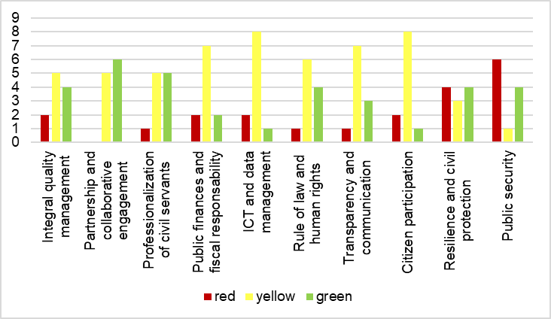
Figure 4: Institutional development for good governance

Figure 4 displays respondents' answers to the first group of questions. The "integral management system" indicator shows that most responses fall into the "yellow" category, indicating a below-acceptable level of practice. Conversely, for "partnership and collaborative arrangement," the majority of respondents fall into the "green" category, meeting an acceptable level. "Professionalization of civil servants" has an equal number of responses in the "yellow" and "green" categories. However, indicators 4 to 8, covering areas like public finances and citizen participation, mostly fall into the "yellow" category, indicating subpar performance. "Resilience and civil protection" has responses split between "red" and "green," suggesting a mix of acceptable and unacceptable practice. Indicator 10 shows the largest number of responses in the "red" category, indicating an unacceptable level of practice for most municipalities.

The second group of questions: Sustainable economic development

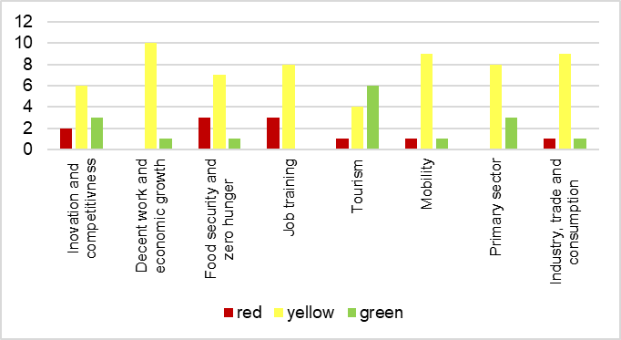
Figure 5: Sustainable economic development

Figure 5 displays respondents' answers to questions from the second group. Only the fifth indicator, "tourism," shows the majority of responses in the "green" category, indicating an acceptable level of practice for most municipalities. However, indicators 1-4 and 6-8, covering areas like innovation, decent work, and industry, predominantly fall into the "yellow" category, suggesting municipalities do not meet acceptable practice levels.

The third group of questions: Inclusive social development

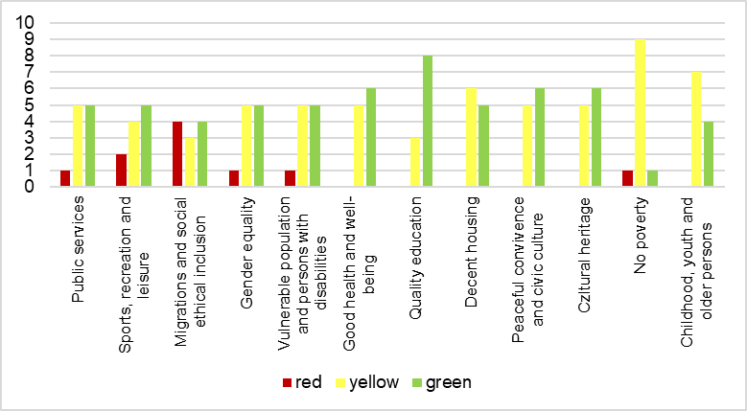
Figure 6: Inclusive social development

Figure 6 presents respondents' answers to questions from the third group. The first indicator, "public services," shows an equal number of responses in the "yellow" and "green" categories, indicating varied practice levels among municipalities. "Sports, recreation and leisure," the second indicator, has the majority of responses in the "green" category, suggesting most municipalities meet acceptable practice levels. For "Migration and socio-ethnic inclusion," responses are split evenly between "red" and "green," highlighting differing levels of practice. "Gender equality" and "Vulnerable population and persons with disabilities" have equal numbers of responses in the "yellow" and "green" categories. Indicators 6, 7, 9, and 10, including "good health and well-being" and "cultural heritage," predominantly fall into the "green" category, indicating acceptable practice levels. However, indicators 8, 11, and 12, such as "dignified housing" and "childhood, youth, and the elderly," primarily fall into the "yellow" category, suggesting subpar performance.

The fourth group of questions: Sustainable development of the environment

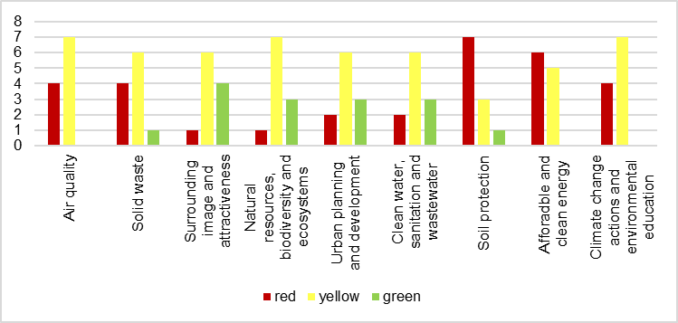
Figure 7: Sustainable development of the environment

Figure 7 depicts respondents' answers to the fourth group of questions. The first six indicators, such as "Air quality" and "Urban planning," mostly fall into the "yellow" category, indicating municipalities generally don't meet acceptable practice levels. "Soil protection" has the majority of responses in the "red" category, representing the highest level of unacceptable practice. Similarly, "Affordable and clean energy" also falls predominantly into the "red" category. The ninth indicator, "Measures related to climate change and environmental education," primarily falls into the "yellow" category, suggesting subpar performance across most municipalities.
8. DISCUSION

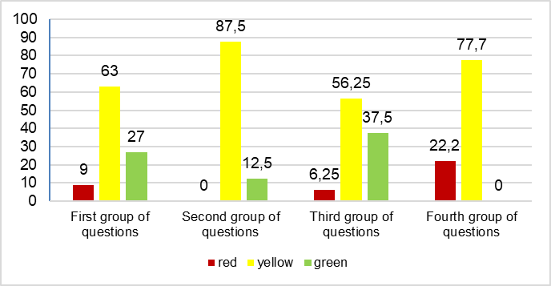
Figure 8: Results summary in percentage

Based on the results of the research, which included about 6% of organizations from the total population, it is possible to give certain guidelines for undertaking adequate activities aimed at fulfilling the requirements from Annex A of the ISO 18091 standard.

Institutional development for good governance, its better practice, in about two-thirds of organizations can achieve through a higher level of activities for integration of management systems, the professionalization of civil servants, public finance and fiscal responsibility, ICT and data management, the rule of law and human rights, transparency and communication and participation of citizens. Finally, a number of organizations, through the indicator of resilience and civil protection and public safety, show either a lack of conditions for their implementation or perform them in an inappropriate manner, which could be determined by additional research.

Sustainable economic development, a group of issues that opens up the opportunities to invest additional effort in all indicators and determine action guidelines, because it is obvious that organizations show a certain ability to maintain the processes in the mentioned indicators, but also that they are insufficient for the minimum acceptability of good practice.

Inclusive social development as a group of issues is the area that is obviously being worked on the most because organizations show the ability to carry out activities, but also that it is necessary to systematically raise the level through various new guidelines in order to reach the result of a minimum of good practices. Given that Inclusive Social Development actually means the inclusion of users, as well as participation, then the level of all services and activities should be minimally satisfied.

Sustainable development of the environment group of indicators, the results of which generally indicate in part the ability of local governments to undertake certain activities regarding all indicators, but that they are not at a sufficient level to qualify as a minimum of good practice. It is also indicative that soil protection and affordable and clean energy are in the zone of no activity or no adequate activity. Sustainable development of the environment refers either to an underdeveloped awareness of the environmental problems of the planet, our country and the local area, or to the absence of material and financial resources.
9. CONCLUSION
It can be concluded that most local government organizations are in the zone of insufficient reliability, that is, that they should make efforts to apply essential elements, but also that they are capable of providing the product/service as required, but that the level of results is still inadequate. A special review should be made on issues of environmental sustainability as well as the inclusion of less interesting groups such as ethical groups and people with poverty problems as very sensitive segments of society. System integration must be a key activity for institutional development, because research has shown that local self-government organizations still have fragmented management systems, and their integration would bring greater benefits than the implementation of these systems. The limitations of this research should certainly be taken into account, first of all the small sample. For further research, they should include a larger number of respondents from the population and the possibility of expanding the questionnaire given within the ISO 18091 standard.

REFERENCES

- Abbas, J. (2020). Impact of total quality management on corporate green performance through the mediating role of corporate social responsibility. Journal of Cleaner Production, 242, 118458.
- Abbas, J., Sagsan, M. (2019). Impact of knowledge management practices on greeninnovation and corporate sustainable development: a structural analysis. Journal of Cleaner Production 229, 611e620.
- Almeida, D., Pradhan, N., &Muniz Jr., J. (2018). Assessment of ISO 9001:2015 implementation factors based on AHP: Case study in Brazilian automotive sector. International Journal of Quality & Reliability Management, 35(7), 1343–1359. https://doi.org/10.1108/IJQRM-12-2016-0228.
- Andrews, R., Ferry, L., Skelcher, C., & Wegorowski, P. (2020). Corporatization in the public sector: Explaining the growth of local government companies. Public Administration Review, 80(3), 482-493.
- Cho, J., & Pyun, J. (2022). A study on the implementation plan for public service quality management applying the ISO 18091 framework. Journal of Korean Society for Quality Management, 50(1), 1-19.
- Council of Europe. (1985). European Charter of Local Self-Government. ETS 122 – Local Self-Government. Strasbourg. (https://rm.coe.int/european-charter-of-local-self-government-eng/1680a87cc3, date of access 01. 02. 2024.)
- Ćwiklicki, M., Pawełek, B., & Pilch, K. (2021). Organisational resource capacity and ISO 9001 QMS Implementation in the Local Government. Evidence from Poland. Public Organization Review, 21(2), 205-219.
- Deleryd, M., & Fundin, A. (2015, October 26–27). The fifth generation of quality concept [Paper presentation]. The World Quality Forum of International Academy for Quality (IAQ), Budapest, Hungary.
- Fernando, Y., Jabbour, C. J. C., Wah, W. X. (2019). Pursuing green growth in technology firms through the connections between environmental innovation and sustainable business performance: does service capability matter? Resour. Conserv. Recycl. 141, 8e20.
- Fundin, A., Lilja, J., Lagrosen, Y., & Bergquist, B. (2020). Quality 2030: quality management for the future. Total Quality Management & Business Excellence, 1-17.
- Gębczyńska, A. L. I. C. J. A., & Wolniak, R. A. D. O. S. Ł. A. W. (2018). Process management level in local government. Philadelphia: CreativeSpace.
- Gunasekaran, A., Subramanian, N., & Ngai, W. T. E. (2019). Quality management in the 21st century enterprises: Research pathway towards Industry 4.0. International journal of production economics, 207, 125-129.
- ISO. (2015). ISO 9000:2015 - Quality management systems — Fundamentals and vocabulary. Zurich, Switzerland: International Organization for Standardization. [https://www.ISO.org/standard/45481.html, date of access: 01. 04. 2024.]
- International Organisation for Standardisation (2024). ISO 9000 Family: Quality management [https:/www.iso.org/standards/popular/iso-9000-family.html, date of access: 04. 04. 2024].
- ISO. (2022). ISO 18091:2022 - Quality management systems - Guidelines for the application of ISO 9001 in local government. Zurich, Switzerland: International Organization for Standardization. [https://www.ISO.org/standard/45481.html, date of access: 01. 04. 2024.]
- ISO. (2022a). ISO Survey. Zurich, Switzerland: International Organization for Standardization. [https://www.iso.org/committee/54998.html?t=KomURwikWDLiuB1P1c7SjLMLEAgXOA7emZHKGWyn8f3KQUTU3m287NxnpA3DIuxm&view=documents#section-isodocuments-top, date of access: 06. 04. 2024.]
- Ji, Q., Zhang, H.Y.( 2019). How much does financial development contribute toRenewable energy growth and upgrading of energy structure in China? Energy Policy 128, 114e124.
- Klochkov, Y. S., & Tveryakov, A. M. (2020). Approaches to the improvement of quality management methods. International Journal of System Assurance Engineering and Management, 11(Suppl 2), 163-172.
- Koskela, L., Tezel, A., & Patel, V. (2019). Theory of quality management: Its origins and history.
- Lee, Yong Wook, Kim, Jin Min, Choi, Sung Yong, & Park, Kyung Bae. (2014). Obstacles in Public Sector TQM and the Strategy to Succeed: Application on Korea Rehabilitation Agency. The Journal of Business Education, 28(6):93-129.
- Li, D., Zhao, Y., Zhang, L., Chen, X., Cao, C., 2018. Impact of quality management on green innovation. Journal of Cleaner Production 170, 462e470.
- Lőffler, E. and Vintar, M. (2004). Improving the Quality of East and West European Public Services. Ashgate Publishing, Bratislava.
- McAdam, R. and Walker, T. (2003). An inquiry into balanced scorecards within best value implementation in UK local government. Public Administration, Vol. 81 No. 4, pp. 873-892.
- Mizuno, K. (2002). Leading by example: local government in Japan adopts ISO 14000 and ISO 9000, funds SME implementation. ISO Management Systems, Vol. 2 No. 3, pp. 21-28.
- Orlovic, P.S., (2015). Ustavnopravni položaj lokalne samouprave u Srbiji. Zbornik radova Pravnog fakulteta, Novi Sad, vol. 49, br. 4, str. 1649-1667
- Potkany, M., Gejdoš, P., Lesnikova, P., & Schmidtova, J. (2020). Influence of quality management practices on the business performance of Slovak manufacturing enterprises. Acta Polytechnica Hungarica, 17(9), 161-180.
- Pittaway, J. J., & Montazemi, A. R. (2020). Know-how to lead digital transformation: The case of local governments. Government information quarterly, 37(4), p.1. 101474.
- Sfakianaki, E., & Kakouris, A. P. (2018). Obstacles to ISO 9001 certification in SMEs. Total Quality Management & Business Excellence, 1–21. https://doi.org/10.1080/14783363.2018.1490640.
- Vukosavljević, D., Kaputo, J., Tešić, A., & Vukosavljević, D. (2021). Makroekonomsko okruženje i javni sektor–mesto i uloga. Oditor, vol. 7, br. 3. pp 37-50. p 41.

