UNLOCKING DIGITAL TRANSFORMATION SUCCESS USING PORTER’S VALUE CHAIN
Abstract. Digital transformation is increasingly becoming a crucial factor for business growth and management across companies of all sizes and industries, offering significant benefits. Despite this, statistics reveal a high failure rate for many digital transformation initiatives. To address this issue, this study conducted a thorough literature review and developed a Porter’s Digital Maturity Model grounded in Porter’s Digital Value Chain and guided by Sociotechnical Systems theory. The model, which consists of seven dimensions and six levels of digital maturity was validated through interviews with five experts from various industry sectors. According to experts, the new model is both detailed and adaptable, making it suitable for different companies, industries, and stages of development across departments, aligning with strategic business objectives. This model empowers companies to precisely assess their level of digital maturity, navigate the process of digital transformation and meet contemporary demands. Additionally, it contributes valuable insights to the body of literature on digital transformation and maturity models.
Keywords: Digital Maturity Model, Digital Transformation, Porter’s Digital Value Chain Model.
- Introduction
Over the years, there has been significant progress in digitalization and the advancement of technologies driving digital transformation across numerous sectors, both in daily life and industry. Digital transformation (DT) has emerged as a key driver of industry and business growth, particularly as the COVID-19 pandemic accelerated online activities by restricting physical interactions [1]. In May 2020, the economic downturn caused numerous businesses to close and led to an estimated loss of 200 million jobs [2]. This crisis significantly hastened DT in various industries, highlighting its importance for ensuring long-term economic growth [3].This digital shift offers a range of advantages, including enhanced efficiency and increased profitability, making it a critical factor for business growth and management across various industries.
Many enterprises lack a clear understanding of their digitalization status, development path, and the necessary methodologies for transformation. Additionally, they often underestimate the significance of digitalization and how it affects their ability to evolve and improve [4]. It is emphasized that companies aiming for transformation must first understand their current maturity stage, identify their strengths and weaknesses, and prioritize areas for improvement to advance effectively [5].
Maturity models are a widely used approach for assessing a company's digitalization needs and its readiness for digital transformation. By determining their level of digital maturity, businesses can customize DT strategies to align with their specific goals, capabilities, and constraints [1]. A Digital Maturity Model (DMM), structured as a series of maturity levels, aims to evaluate and benchmark an organization's current digital maturity against a target level [6]. According to Web of Science, 45.271 papers focus on DMMs and DT, with approximately 60% of these published within the last five years. Despite the abundance of these models in the literature, 90% of DT projects do not achieve their intended outcomes [7].
Considering that DT affects the social, technological, and managerial aspects across every level of the organization [8], it must be approached with a holistic management strategy [9]. However, it is notable that a comprehensive, holistic model is still absent from the existing literature [9]. Although DMMs are, by definition, expected to outline a predefined path toward digital maturity, most of the existing publications don’t propose specific actions or guidelines for achieving this goal [10, 11]. Additionally, P. Senna et al. [12] point out that many existing DMMs face challenges with generalizability and lack a strong theoretical foundation. When introducing DT to an organization, it is important to recognize that different business areas may have varying needs for digitalization and differing levels of susceptibility to such a transformation. Each area may require tailored approaches depending on its specific requirements and readiness for change [13]. Another important point is that the creation of digital value is often overlooked in the development of DMM even though DT fundamentally reshapes how value is generated [14]. In the existing models, based on the analysis by Aras & Büyüközkan [9], the concept of digital value is mentioned 43 times, underscoring its significance. Contradictorily, value chains are referenced only twice in the available DMMs.
The goal of value chain analysis is to help a company position itself competitively by identifying its strengths and demands, ultimately guiding the pursuit of sustainable competitive advantage, especially in a changed digital environment [15]. The value chain concept has been championed by Porter [16] for over three decades and is noted as both popular and effective [17]. Out of 315 papers on Porter's value chain indexed in the Web of Science, only 12 have utilized this model within the context of information technology. This highlights a considerable gap in the research and points to a potential area for future studies.
Therefore, this study aims to address the previously mentioned challenges and fill existing gaps in the literature by:
(1) Developing a descriptive digital transformation maturity model based on digitalized Porter’s Value Chain model, focusing on value creation.
(2) Proposing a theoretically grounded model with specific actions to guide organizations through successful digital transformation.
(3) Designing a model that can be easily adapted to different industries and company-specific needs.
- Literature review
  - Organizational changes driven by Digital Transformation
In the era of the fourth industrial revolution, DT plays a pivotal role in shaping both business environments and everyday experiences, emphasizing the far-reaching effects of digitalization throughout society [18]. DT refers to the incorporation of digital technology across every aspect of a business [19]. Traditional business processes and methods are evolving to align with the demands of DT [20], incorporating advanced technologies such as the Internet of Things, artificial intelligence, blockchain and cloud computing. These innovations drive substantial operational shifts and enable the development of new business models [3] and organizational solutions [21].
A key element of DT is fostering organizational awareness that digitalization extends beyond simply implementing information and communication technologies. It involves profound changes in organizational strategy, business processes, knowledge management, and the entire socio-technical system of the organization [13]. DT reshapes the company as a whole [22] and drives exceptional performance by impacting both internal and external organizational elements [3, 13]. According to earlier studies [14, 23], successful DT requires a comprehensive evaluation that encompasses technology implementation, organizational obstacles, structural modifications, and transformations in value creation. Accordingly, Matt et al. [14] argue that DT is a critical strategic concern that influences multiple areas of a business. Its impact extends beyond the organization itself, affecting processes, products, production methods, supply chains, and sales channels.
Transitioning to digital activities enables organizations to diversify and improve their offerings, but it also introduces challenges. These challenges include the demand for new technological expertise and increased risks due to a lack of experience in digital domains. Organizations also encounter significant challenges in aligning appropriate digital strategies and actions during their DT journey, primarily due to the inherent complexities of IT administration and the limited research available on systematic approaches to digital transformation adoption [9]. Structural adjustments within the organization may be required to effectively support new digital initiatives [14]. Organizational structures should be tailored to the scale of the transformation. For smaller changes, new processes can be seamlessly incorporated into the existing frameworks [23].
The integration of modern technologies in business frequently results in substantial shifts in value creation, disrupting traditional value chains. Businesses have become increasingly aware of digitalized value chains, with each striving to maximize the value they bring to their organizations [24]. To remain competitive, organizations are transforming their traditional value creation methods by embracing a range of digital technologies [20].
  - Theoretical Frameworks for Understanding Digital Transformation's Influence on Organizational Change
Numerous theories in the literature have extensively examined the connection between technological adoption and changes within organizations.
Bruno Latour's actor-network theory (ANT) integrates the social and material worlds, viewing them as inherently linked [25]. However, Modell [26] criticizes ANT for placing too much emphasis on individual actions while overlooking broader social structures that influence organizational changes, such as digital transformation (DT). This critique highlights ANT's limitations in capturing the more complex structural dynamics at play.
Leonardi [27] explains that sociomaterial theory posits that the material properties of technology and social interactions are intertwined and cannot be separated. While society plays a role in shaping the design and function of technology, once it is developed, technology is seen as a fixed entity to which people must adjust in their daily routines [27]. However, this theory may be insufficient for analyzing organizational changes driven by digital transformation, as it primarily focuses on local-level interactions between technology and social practices and does not accept a clear distinction between humans and technology [28].
Structuration theory posits that social structures, such as organizational frameworks, are both the result of and influence human actions. However, Jones & Karsten [29] critique the theory for not adequately addressing the role of technology in shaping social structures or driving major organizational transformations.
Sociotechnical systems (STS) theory emphasizes that organizational changes must consider both technical and social factors, viewing the organization as an interconnected system where alterations in one area impact others. This holistic perspective encompasses the organization's structure, culture, and skill sets, providing a valuable approach for managing transformations brought about by technological advancements [20]. As a result, STS theory serves as a useful framework for this study.
  - Digital Maturity Models
Digital maturity plays a crucial role in the context of DT. It represents an organization's current capacity to leverage digital technologies to enhance innovation, efficiency, and competitiveness [30].
The terms "readiness" and "maturity" represent different phases in evaluating an organization's progress toward DT. "Readiness" is an initial assessment that gauges whether the organization is prepared to embark on digital transformation, focusing on its capability to begin the process. On the other hand, "maturity" evaluates the organization's current state, measuring its level of digital sophistication and the extent to which digital technologies have been integrated into its operations [6].
Maturity models help organizations navigate DT by assessing their digital capabilities and pinpointing areas for improvement [30]. According to Johnson and Uwaoma [30], these models serve as both roadmaps for transformation and tools for evaluating digital strengths and weaknesses, aiding in strategic planning and increasing business agility. Additionally, they monitor progress through various maturity stages, ultimately enhancing overall business capabilities. DMMs offer a clear direction for organizations, guiding both their digital strategy and transformation process [31].
Ladu et al. [32] found no universal DMM, but instead identified 140 diverse models varying by industry, scope, and focus on internal factors like institutional, organizational, and technical capabilities. These models differ in both the dimensions they cover and the number of maturity stages.
A review of the literature reveals significant criticism of current DMMs. Experts disagree on their practical and research contributions, citing a lack of objective evaluation criteria and empirical data to support the link between maturity and performance. Some even question the necessity of these models. As a result, scholars agree that there is a clear knowledge gap and call for further research to determine how DMMs provide value compared to traditional methods of identifying improvement opportunities [31]. Scholars consider it essential for DMMs to offer a more comprehensive understanding of digital transformation and its unique characteristics across different industries [33].
- Methodology
  - Value Chains Comparison
Introduced by Porter in 1985 through his book "Competitive Advantage: Creating and Sustaining Superior Performance," the value chain model has since become a cornerstone for analyzing value creation and understanding the roles of different activities and sectors within organizations. This model maps out the sequence of activities, from pre-production to final delivery, that make up the value chain. These organizational activities are divided into primary and support functions, both of which work together to drive the organization's profit margin [16].
Over the past 25 years, various approaches to value chain analysis have emerged due to challenges in applying the original framework, particularly in service industries. While the value chain's core logic is universally applicable, its activity categories suit manufacturing better than services [34].
Recognizing this, Stabell & Fjeldstad [35] introduced alternative configurations like the value shop and value network, addressing limitations in the traditional model. Stabell & Fjeldstad [35] describe the value shop framework as fitting organizations offering highly customized services, such as those in medicine, engineering, law, or architecture. These firms rely on the expertise and skills of their staff, adding value by creatively and effectively solving client problems [15]. Unlike the value chain model, which focuses on producing standardized products through a set sequence of activities, the value shop adapts its actions and resources to address specific client needs [36]. However, this approach may not easily scale across a broad customer base or adapt to automated processes, which are key drivers of DT success [37].
Value networks use mediating technology to connect clients or users who depend on each other. Unlike value chains, which focus on production, value networks emphasize the role of intermediaries who create value by linking clients in a standardized, coordinated way [15]. McIvor [38] adds that value networks function as brokers, facilitating interactions between buyers and sellers, and profiting from these connections. Examples of such organizations include retail banks, telecommunications companies, and insurers. Value networks prioritize connectivity and standardization over innovation. DT, on the other hand, emphasizes rapid technological change, innovation, and personalization, which requires more than just coordination [36]. Additionally, DT relies heavily on the use of big data, artificial intelligence and machine learning to optimize and personalize customer experiences [39]. The value network model, however, focuses on facilitating transactions between clients rather than leveraging data to drive continuous innovation and improvement.
Webb & Gile [40] criticized the traditional value chain model for focusing too much on core competencies rather than customer needs. They proposed the reversed value chain model, which prioritizes understanding and adapting to customer requirements to gain a competitive advantage, particularly in dynamic fields like e-commerce [15]. Digital transformation requires the seamless integration of new technologies like AI, cloud computing, and big data analytics. While the reversed value chain prioritizes customer needs, it might not fully address the necessity of integrating cutting-edge technologies to optimize processes, which is critical in DT [41].
As DT impacts all aspects of an organization, Porter’s Digital Value Chain Model (DVCM), shown in Figure 1, was developed to build upon Porter’s framework and be applicable across various industries. This model highlights key digital activities that drive value and competitive advantage, such as digital supply chain, digital customer experience and operations, human resource management, marketing and workplace, with data analytics and information and communication technology (ICT) development as crucial enablers [42]. Compared to other models, the DVCM enables scalability, emphasizes the use of data at every stage of the process, and is adaptable to technological enhancements. These aspects are particularly highlighted through the incorporation of the ICT model, which plays a crucial role in supporting digital processes. The integration of technologies such as cloud computing, data analytics, and AI allows companies to scale operations, optimize their processes, and make data-driven decisions, making the DVCM highly suitable for the demands of modern business environments and suitable model for this study.
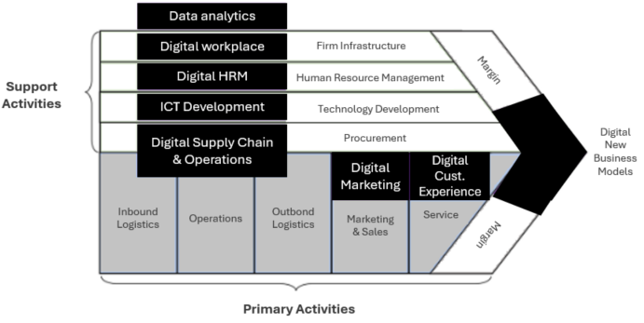
Fig. 1. Porter’s Digital Value Chain Model [42]
  - Maturity Levels
A maturity level in a maturity model represents the extent to which an organization has optimized its processes, behaviors, or capabilities. Each level signifies a stage of development, with higher levels indicating more advanced and refined practices. An organization's maturity level reflects its overall performance and can be described as an evolutionary stage in its journey toward improving organizational maturity [11]. One of the identified shortcomings of existing DMMs is that a small percent of them offer specific actions or guidelines for achieving digital maturity [10]. This issue can be addressed by introducing maturity levels, as they consist of specific practices and general actions that target different areas for improvement, ultimately helping to enhance the overall maturity of an organization [11]. Their importance has been increasingly recognized over time, with more than half of existing maturity models now incorporating maturity levels [6]. Based on the previously mentioned reasons, maturity levels will also be incorporated into our DMM.
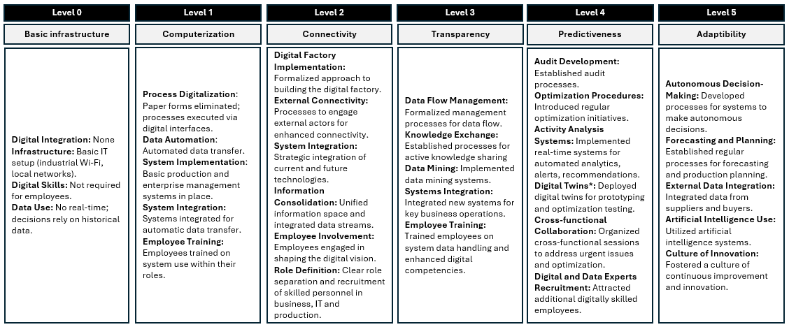
In their study [43], Ilin et al. reviewed a wide range of maturity models, such as CMMI, SPICE PMMM, SW CMM, , ISO 15504, BPMM, COBIT 4.1 and OPM3, identifying a total of five maturity levels, along with an additional level 0. Each level is carefully outlined, considering factors related to processes, technologies, and employee attributes. This framework was chosen for the current research due to its depth and ability to comprehensively address these key areas. The levels are illustrated in Figure 2.
Fig. 2. Digital Maturity levels (Adapted according to Ilin et al. [43])
* Digital twins are virtual representations of physical objects that enable real-time monitoring and optimization.
  - Method
The maturity model’s development method involves three stages (Figure 3).
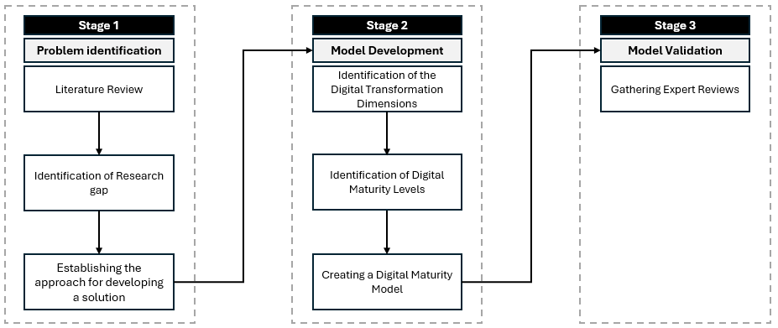
Fig. 3. Model development process (Source: Authors’ work)
The first stage focuses on problem identification, beginning with a Literature Review. This review was conducted using the Web of Science database, selecting only relevant articles (SCIE and SSCI) and book chapters from the past 10 years. A total of 6,769 publications were found, underscoring the significance and growing attention to this topic.
The literature review reveals that many existing DMMs lack a solid theoretical foundation [12]. Notably, there is still a lack of a comprehensive, holistic model in the current research landscape [9]. While DMMs are designed to guide organizations toward digital maturity, only about one-third of the studies offer concrete actions or guidelines for this process [10]. Additionally, many models tend to assess digital maturity uniformly across an organization, overlooking differences in digital advancement between various areas [13]. Lastly, the generation of digital value is often neglected, despite its central role in digital transformation [14].
As discussed in the previous chapter, digital transformation requires significant organizational changes, particularly in how value is created and in updating existing processes [14]. This led to further exploration of value creation models, resulting in the adoption of the Digitally modified Value Chain framework [42], which addresses the limitations of other models, as noted in section 3.1. Furthermore, the research examined studies using Porter's Value Chain in the context of information technology (IT). Findings reveal that only 315 papers relate to the Digital Porter’s Value Chain, and just 12 (3.8%) of these apply the model specifically in the IT context, highlighting a major research gap in this area.
The final activity of the first phase is to determine the approach for developing a solution. Based on the literature review and identified research gaps, it is concluded that the new model should be comprehensive, detailed, and holistic. It should propose clear actions and guidelines, allow digital maturity to be assessed according to the needs and possibilities of a specific business area, and focus on the creation of digital value.
The second stage, Model Development, involved defining DT Dimensions and establishing appropriate digital maturity levels to build the model. In line with the explanations provided in the previous sections, Porter’s Digital Value Chain [42] was chosen for this study, along with the six maturity levels identified by Ilin et al. [43].
The third stage, Model Validation, involved obtaining feedback from six industry experts to ensure a comprehensive evaluation of the model. Each expert was given 2–3 days to review the model, followed by short online interviews lasting 30-45 minutes. These discussions focused on the model's functionality, strengths and weaknesses. The initial feedback from these interviews is summarized in the "Model Validation" chapter, offering valuable insights into the model’s practical use and identifying areas for improvement.
- Porter’s Digital Maturity Model
Newly created, Porter’s Digital Maturity Model (PDMM) comprises seven dimensions and five levels of digital maturity, along with an additional Level 0. The model is detailed in Figure 4. In this model, the explanations within squares represent DT implementation strategies, which consist of programs, or a series of projects implemented across the organization. These strategies guide the organization through different stages of digital maturity.
Each iteration of DT progressively transforms business processes by strengthening key capabilities and gradually raising the organization’s digital maturity over time. The overall transformation journey is shaped by the effective execution of each strategy, as these strategies guide the organization through key stages of digital maturity, ensuring continuous improvement and growth.
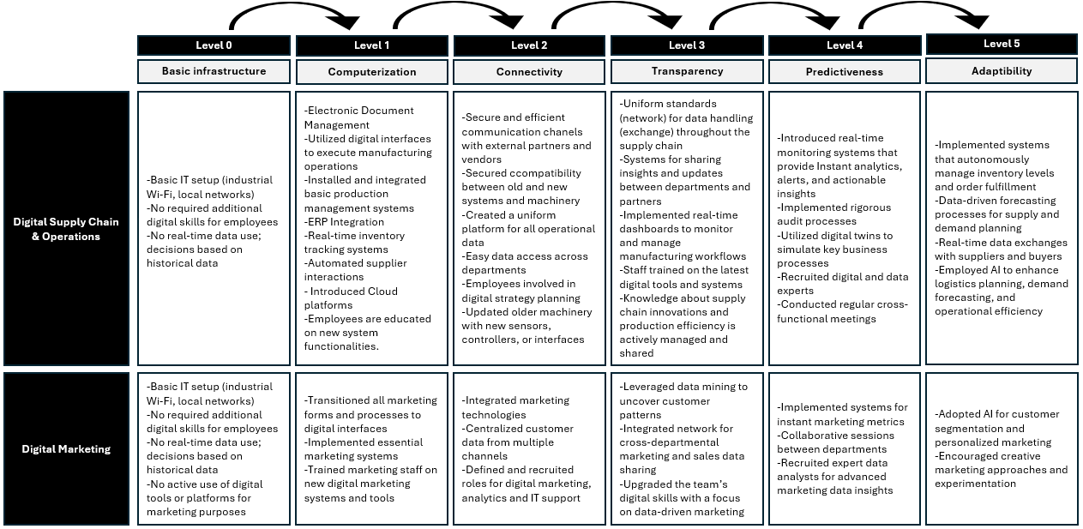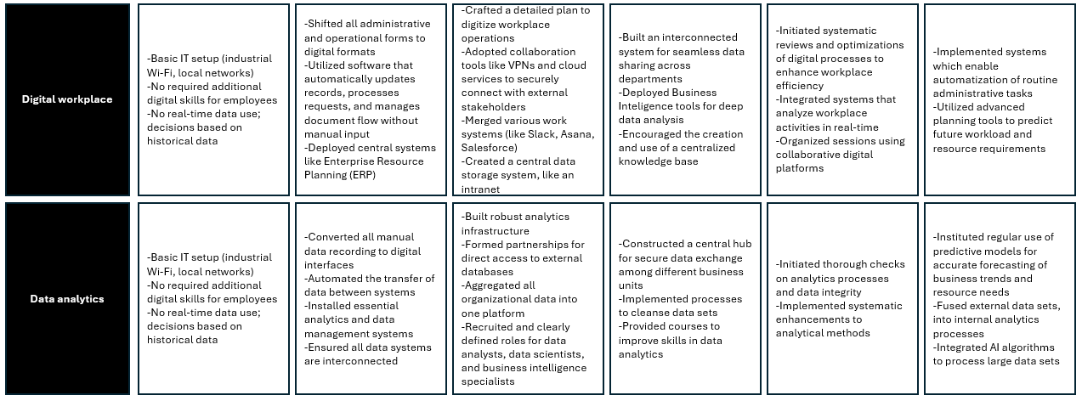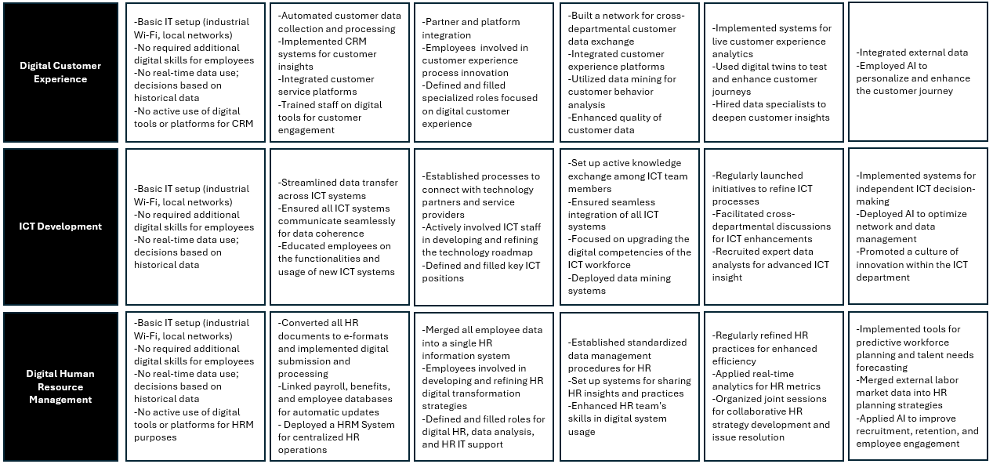Fig. 4. Porter’s Digital Maturity Model (Source: Authors’ work)
  - Model Validation
For the model validation, interviews were conducted with experts, and their demographic details along with their feedback are summarized in Table 1.
Table 1. Experts Interviews Summary
Expert | Education Level | Industry | Years of Experience | Strength/Weaknesses | Comments
1 | PhD | Paper | 15 | Strengths: Suitable for all service industries that need a clear roadmap for digital transformation to enhance their processes and deliver improved services to their clients.  Weaknesses: Greater emphasis is needed on traditional manufacturing activities, as reaching levels 4 and 5 proves particularly difficult for manufacturing industries. | “The model has been meticulously prepared and thoroughly explained. The model is particularly suitable for the IT sector and similar service industries like online marketplaces.”
2 | Master | Information Technology | 7 | Strengths: It is thoroughly detailed, placing a strong emphasis on improving both internal and external organizational connections, adaptable to various types of companies, and highlights the importance of employee education.  Weaknesses: High implementation costs, challenging for small and medium-sized enterprises | “The model is easily applicable and very detailed.  When applying this model, both global and local specifics should be considered.”
3 | Bachelor | Supply Chain & Logistics | 12 | Strengths: Very comprehensive model, it is clear what the next steps are in the progression process, transparency is often highlighted  Weaknesses: It is not always easy to determine the benefits or the return on investment | “The Model should include elements of sustainability and scalability of implemented technologies.  Anyhow it is very useful for high-level managers”
4 | Bachelor | Fast-Moving Consumer Goods | 16 | Strengths: Clarity and Transparency, easy company self-assessment.  Weaknesses: It largely depends on the company's digital literacy and goals, the focus of top management, and the willingness to invest in this direction (both financially and through training existing staff). | “In companies, the biggest challenge often lies with older employees and departments with low staff turnover, as these workers tend to resist acquiring new skills and adapting to change. Departments such as finance and accounting (excluding controlling and internal audit), order-to-cash, and factory operations (including warehousing, production, and quality control) may be particularly affected by this reluctance to embrace digital transformation.”
5 | Master | Information Technology Audit | 5 | Strengths: Clear Progression Path, Customization for Different Functions, Focus on Data-Driven Insights  Weaknesses: For organizations at lower maturity levels, jumping from basic infrastructure to higher stages may seem overwhelming. Certain areas, like HR or finance, might face internal resistance to digital transformation, especially in departments with low turnover and employees less open to adopting new technologies. | “The model could be customized for specific industries by adapting it to address their unique regulatory, operational, and customer-facing needs”.  “believe you should incorporate change management strategies, especially in departments or areas more resistant to digital changes, to ensure a smooth transformation “

- Discussion
Based on the literature review and identified research gaps, it has been determined that the new model must be comprehensive, detailed, and holistic. It should offer clear actions and guidelines, allowing digital maturity to be assessed not as a whole, but according to specific business areas. Additionally, the model should emphasize the creation of digital value, ensuring that the transformation contributes directly to enhancing the organization's capabilities and competitive advantage in the digital space. Porter’s Digital Value Chain [42] was selected for this study, together with the six maturity levels outlined by Ilin et al. [43].
Digital transformation fundamentally alters how value is created, leading to the development of new digital business models [14]. Recognizing a gap in the literature, researchers such as Holopainen et al. [23] and Margiono [44] have examined the evolving methods of value creation in the digital age. Our work addresses this gap by integrating the Digital Porter's Value Chain [42], focusing explicitly on value creation within the context of DT. This integration ensures that value generation remains at the core of organizational evolution in the digital era.

If an organization is resistant to changing its operations, DT efforts are likely to fail [45]. The newly created PDMM understands the significance of organizational operations and classifies them into primary and support activities in line with Porter's framework [16] and Porter’s Digital Value Chain Model developed by Türkmen and Soyer [42]. This ensures that the model addresses the key operational and technological areas necessary for successful DT.
Unlike previous models, which require a company to position itself at a single maturity level based on its overall digitalization [30, 46, 6], this model offers the advantage of considering different development levels across various departments. For instance, a paper industry company may have little need for digital marketing, positioning itself at level 0 or 1 in that area, while being at level 3 or 4 in Digital Supply Chain & Operations. The PDMM offers general guidelines that are flexible and adaptable across different industries and companies. It allows businesses to position themselves at various maturity levels based on their specific activities and needs. This approach also considers the company’s strategic orientation, the same as in the research conducted by Kırmızı & Kocaoglu [47].
Assessing process maturity allows organizations to gauge how effectively their processes are managed and optimized. As companies grow, they advance through different maturity stages, each characterized by specific management and strategic traits. These stages prepare businesses for more efficient process implementation at the next level. Since many companies may not fully understand the complexities of the digital landscape, conducting a comprehensive assessment can reveal areas for potential growth. Knowing the company’s current maturity level helps formulate a successful digital strategy [43].
According to experts’ feedback, PDMM enables managers to accurately assess their company's digital maturity. The detailed descriptions within the model provide a solid foundation for formulating digital strategies and planning future steps [14]. Experts also praise the model for its adaptability across different industries, addressing one of the key shortcomings identified in the literature, which is the overgeneralization of digital maturity models [12]. However, while the current version is considered highly suitable for service industries, there is potential for future adaptations to cater more specifically to other sectors. As Expert 1 points out, digital development can be more financially intensive in certain industries, such as manufacturing, compared to others [48]. Thus, reducing the requirements based on financial and process complexity could make the model more accessible and practical for companies in different industries.
As Ladu et al. [32] argue, the adoption of innovations like digital technologies is often hindered by various constraints that prevent successful implementation. Therefore, the reluctance and challenges organizations face in advancing their digital maturity can largely be attributed to limited time resources and the complexity of their tasks. The complexity of DT is such that it cannot be adequately addressed by a single holistic model for all purposes [49].Therefore, it is crucial to define the field of application for DMMs as specifically as possible, considering factors such as the business sector and company profile.
In Sociotechnical Systems theory, the effective collaboration between social (employees and processes) and technical (technology) elements is essential for achieving organizational goals. Our findings confirm that employees, processes, and technology are all critical factors in delivering successful digital transformation outcomes in line with Imran et al. [20]. These components must be integrated across every level and dimension of the organization, driving key goals such as adaptability and transparency. By ensuring alignment between these elements, organizations can better navigate the complexities of digital transformation and achieve sustained performance improvements.
Both academics and practitioners assert that as organizations progress on their path to digital maturity, their attractiveness for investment and competitive advantage significantly increase [50].
- Conclusions and future directions
The main objective of this research was to create a descriptive digital transformation maturity model that fills the existing gaps in the current research. This study addresses key challenges and fills gaps in the literature by developing a descriptive digital transformation maturity model, grounded in the digitalized Porter's Value Chain, with a strong focus on value creation; offering a theoretically founded model that guides organizations through the complexities of digital transformation and designing a flexible model that can be easily adapted to the needs of different industries and companies. Grounded in Sociotechnical Systems theory and incorporating the Digital Porter's Value Chain, with a comprehensive outline of six maturity levels spanning all value chain activities, Porter’s Digital Maturity Model addresses existing research gaps and establishes a robust foundation for the development of industry-specific models.
This model assists organizations in successfully navigating digital transformation, promoting excellent performance by offering guidelines to managers and employees for implementing digital transformation.
One of the challenges related to the Porter’s Digital Maturity Model is that in its further development, model does not become overly complex so it ultimately becomes inefficient and unflexible.
In this research, the evaluation of the model was restricted to only five experts, which may not offer a fully comprehensive assessment. Future research could focus on further validating the model by conducting additional interviews and applying it in real-world scenarios across various industries. Moreover, the model could be customized to suit the specific needs of different sectors..
In future research, the application of the proposed model should be aligned with strategic analysis and organizational development objectives to more effectively establish priorities for both organizational growth and DT.
In future research, it might be valuable to consider developing distinct models for service and manufacturing sectors, as well as industry-specific models for areas like IT, agriculture, finance, and tourism. Additionally, introducing a structured questionnaire for top managers to assess their organization’s digital maturity could enhance practical usability. Another key consideration is enabling comparisons between organizations within the same sector, as digital transformation varies across industries. While operations differ significantly between sectors, areas like HR, accounting, and marketing offer opportunities for cross-industry benchmarking.

References
- Ka, X., Ying, T., Tang, J.: A Conceptual Model for Developing Digital Maturity in Hospitality Micro and Small Enterprises. Journal of Theoretical and Applied Electronic Commerce Research, 18, 1511–1528 (2023). https://doi.org/10.3390/jtaer18030076.
- United Nations: World Youth Report: Youth Social Entrepreneurship and the 2030 Agenda. (2020).
- Shanti, R., Siregar, H., Zulbainarni, N., Tony: Role of Digital Transformation on Digital Business Model Banks. Sustainability, 15, 16293 (2023). https://doi.org/10.3390/su152316293.
- Li, L.: Evaluation of Digital Transformation Maturity of Small and Medium-Sized Entrepreneurial Enterprises Based on Multicriteria Framework. Mathematical Problems in Engineering, 2022, 1–11 (2022). https://doi.org/10.1155/2022/7085322.
- Bibby, L., Dehe, B.: Defining and assessing industry 4.0 maturity levels – case of the defence sector. Production Planning & Control, 29, 1030–1043 (2018). https://doi.org/10.1080/09537287.2018.1503355.
- Haryanti, T., Rakhmawati, N.A., Subriadi, A.P.: The Extended Digital Maturity Model. Big Data and Cognitive Computing, 7, (2023). https://doi.org/10.3390/bdcc7010017.
- Ramesh, N., Delen, D.: Digital Transformation: How to Beat the 90% Failure Rate? IEEE Engineering Management Review, 49, 22–25 (2021). https://doi.org/10.1109/EMR.2021.3070139.
- Jevtić, M., Cicvarić Kostić, S., Okanović, M.: Communication Aspect of National Testing Digitalization: Investigating Key Stakeholders’ Satisfaction. Management: Journal of Sustainable Business and Management Solutions in Emerging Economies, (2024). https://doi.org/10.7595/management.fon.2024.0003.
- Aras, A., Büyüközkan, G.: Digital Transformation Journey Guidance: A Holistic Digital Maturity Model Based on a Systematic Literature Review. Systems, 11, (2023). https://doi.org/10.3390/systems11040213.
- Khoi Nguyen, D., Broekhuizen, T., Qi Dong, J., Verhoef, P., Khoi, D., Qi, J.: Digital readiness: construct development and empirical validation. In: Fortieth International Conference on Information Systems, Munich (2019).
- Teichert, R.: Digital Transformation Maturity: A Systematic Review of Literature. Acta Universitatis Agriculturae et Silviculturae Mendelianae Brunensis, 67, 1673–1687 (2019). https://doi.org/10.11118/actaun201967061673.
- P. Senna, P., Barros, A.C., Bonnin Roca, J., Azevedo, A.: Development of a digital maturity model for Industry 4.0 based on the technology-organization-environment framework. Computers & Industrial Engineering, 185, 109645 (2023). https://doi.org/10.1016/j.cie.2023.109645.
- Tubis, A.A.: Digital Maturity Assessment Model for the Organizational and Process Dimensions. Sustainability, 15, (2023). https://doi.org/10.3390/su152015122.
- Matt, C., Hess, T., Benlian, A.: Digital Transformation Strategies. Business & information systems engineering, (2015). https://doi.org/10.1007/s12599-015-0401-5.
- Ďurišová, J.: Value Chain Analysis And Its Position Within Other Value-Oriented Concepts. Scientific papers of the University of Pardubice, Series D, Faculty of Economics and Administration, 16 (1/2010) (2010).
- Porter, M.E.: Competitive Advantage: Creating and Sustaining Superior Performance. Free Press: New York, NY, USA (1985).
- Nagy, J., Oláh, J., Erdei, E., Máté, D., Popp, J.: The role and impact of industry 4.0 and the internet of things on the business strategy of the value chain-the case of Hungary. Sustainability, 10, (2018). https://doi.org/10.3390/su10103491.
- Mitrović, Z., Bjelica, D., Borozan, T.: Are Future Project Managers Ready for a Digitalized World?. In International Symposium SymOrg, pp. 525-543, Springer International Publishing, Belgrade (2023). https://doi.org/10.1007/978-3-031-18645-5_33.
- Horlach, B., Drews, P., Schirmer, I., Böhmann, T.: Increasing the Agility of IT Delivery: Five Types of Bimodal IT Organization. In: Proceedings Of The 50th Annual Hawaii International Conference On System Sciences. pp. 5420–5429 (2017).
- Imran, F., Shahzad, K., Butt, A., Kantola, J.: Digital Transformation of Industrial Organizations: Toward an Integrated Framework. Journal of Change Management, 21, 451–479 (2021). https://doi.org/10.1080/14697017.2021.1929406.
- Ćudanov, M., Jaško, O., Jevtić, M.: Influence of information and communication technologies on decentralization of organizational structure, Computer Science and Information Systems. 6, 93–109 (2009). https://doi.org/10.2298/CSIS0901093C.
- Hein-Pensel, F., Winkler, H., Brückner, A., Wölke, M., Jabs, I., Mayan, I.J., Kirschenbaum, A., Friedrich, J., Zinke-Wehlmann, C.: Maturity assessment for Industry 5.0: A review of existing maturity models. Journal of Manufacturing Systems, 66, 200–210 (2023). https://doi.org/10.1016/j.jmsy.2022.12.009.
- Holopainen, M., Saunila, M., Ukko, J.: Value creation paths of organizations undergoing digital transformation. Knowledge and Process Management, 30, 125–136 (2023). https://doi.org/10.1002/kpm.1745.
- Chhabra, A., Botos, S., Felfoldi, J.: Digitized Value Chain in Food Industries: Opportunities and Challenges for SMEs. SEFBIS Journal, 1–10 (2023). https://doi.org/10.14267/SEFBIS.2023.02.
- Latour, B.: Reassembling the Social An Introduction to Actor-Network-Theory. Oxford University Press (2005).
- Modell, S.: For structure: A critical realist critique of the use of actor-network theory in critical accounting research. Accounting, Auditing & Accountability Journal, 33, 621–640 (2019). https://doi.org/10.1108/AAAJ-01-2019-3863.
- Leonardi, P.M.: Theoretical foundations for the study of sociomateriality. Information and Organization, 23, 59–76 (2013). https://doi.org/10.1016/j.infoandorg.2013.02.002.
- Orlikowski, W.J., Scott, S. V.: Sociomateriality: Challenging the Separation of Technology, Work and Organization. Academy of Management annals, 2, 433–474 (2008). https://doi.org/10.1080/19416520802211644.
- Jones, Karsten: Giddens’s Structuration Theory and Information Systems Research. MIS Quarterly, 32, 127-157 (2008). https://doi.org/10.2307/25148831.
- Johnson, F.K., Uwaoma, C.C.: Building a Better Digital Maturity Model for Midsize Businesses in a Post-Pandemic World. The IUP Journal of Operations Management, 22, 24-43 (2023).
- Thordsen, T., Bick, M.: A decade of digital maturity models: much ado about nothing? Information Systems and e-Business Management, 21, 947–976 (2023). https://doi.org/10.1007/s10257-023-00656-w.
- Ladu, L., Koch, C., Asna Ashari, P., Blind, K., Castka, P.: Technology adoption and digital maturity in the conformity assessment industry: Empirical evidence from an international study. Technology in Society, 77, (2024). https://doi.org/10.1016/j.techsoc.2024.102564.
- Carvalho, J.V., Rocha, Á., van de Wetering, R., Abreu, A.: A Maturity model for hospital information systems. Journal of Business Research, 94, 388–399 (2019). https://doi.org/10.1016/j.jbusres.2017.12.012.
- 34. Laffey, D., Gandy, A.: Applying Stabell and Fjeldstad’s value configurations to E-commerce: A cross-case analysis of UK comparison websites. The Journal of Strategic Information Systems. 18, 192–204 (2009). https://doi.org/10.1016/j.jsis.2009.10.002.
- Stabell, C.B., Fjeldstad, Ø.D.: Configuring Value for Competitive Advantage: On Chains, Shops, and Networks. Strategic Management Journal, 19, 413–437 (1998).
- Wodecki, A.: Value Creation and Competitive Advantage Models. In: Artificial Intelligence in Value Creation. pp. 1–70. Springer International Publishing, Cham (2019). https://doi.org/10.1007/978-3-319-91596-8_1.
- Mihu, C., Pitic, A.G., Bayraktar, D.: Drivers of Digital Transformation and their Impact on Organizational Management. Studies in Business and Economics, 18, 149–170 (2023). https://doi.org/10.2478/sbe-2023-0009.
- McIvor, R.: The Outsourcing Process: Strategies for Evaluation and Management. Cambridge University Press (2005).
- Huang, J.: Building Intelligence in Digital Transformation. Journal of Integrated Design and Process Science, 21, 1–4 (2018). https://doi.org/10.3233/jid-2018-0006.
- Webb, J., Gile, C.: Reversing The Value Chain. Journal of Business Strategy, 22, 13–17 (2001). https://doi.org/10.1108/eb040151.
- Mikalef, P., Parmiggiani, E.: An Introduction to Digital Transformation. In: Digital Transformation in Norwegian Enterprises, pp. 1–10. Springer International Publishing, Cham (2022). https://doi.org/10.1007/978-3-031-05276-7_1.
- Türkmen, E., Soyer, A.: The effects of digital transformation on organizations. In: Handbook of Research on Strategic Fit and Design in Business Ecosystems. pp. 259–288. IGI Global (2019). https://doi.org/10.4018/978-1-7998-1125-1.ch011.
- Ilin, I., Borremans, A., Levina, A., Esser, M.: Digital Transformation Maturity Model. In: Digital Transformation and the World Economy. Studies on Entrepreneurship, Structural Change and Industrial Dynamics, pp. 221–235. Springer Nature (2022). https://doi.org/10.1007/978-3-030-89832-8_12.
- Margiono, A.: Digital transformation: setting the pace. Journal of Business Strategy, 42, 315–322 (2020). https://doi.org/10.1108/JBS-11-2019-0215.
- Tabrizi, B., Lam, E., Girard, K., Irvin, V.: Digital Transformation Is Not About Technology, https://hbr.org/2019/03/digital-transformation-is-not-about-technology, last accessed 2024/04/26.
- Kozina, M.: Framework for Assessing the Company’s Maturity of Digital Business Transformation. In: 40th International Scientific Conference on Economic and Social Development, pp. 80–87 (2019).
- Kırmızı, M., Kocaoglu, B.: Digital transformation maturity model development framework based on design science: case studies in manufacturing industry. Journal of Manufacturing Technology Management, (2022). https://doi.org/10.1108/JMTM-11-2021-0476.
- Gandhi, P., Khanna, S., Ramaswamy, S.: Which Industries Are the Most Digital (and Why)?, https://hbr.org/2016/04/a-chart-that-shows-which-industries-are-the-most-digital-and-why, last accessed 2024/05/03.
- Álvarez Marcos, J., Capelo Hernández, M., Álvarez Ortiz, J.: The digital maturity of the Spanish press. A case study. La Laguna, Tenerife (2019). https://doi.org/10.4185/RLCS-2019-1342en.
- Korachi, Z., Bounabat, B.: Towards a Maturity Model for Digital Strategy Assessment. In: Advances in Intelligent Systems and Computing, pp. 456–470. Springer Science and Business Media Deutschland GmbH (2020). https://doi.org/10.1007/978-3-030-36674-2_47.

